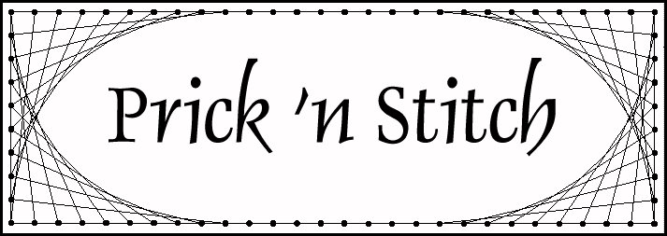
Design contains the
Prick ‘n Stitch Pattern & Instruction Sheet plus an extra Pricking Pattern.

IMPORTANT

Please respect the many hours the designers have
Worked on these designs.
We ask you not make copies for friends,
re-sale or teaching purposes.
As this is an infringement of our copyright.

However, you are free to make cards yourself from the patterns
for your personal use or resale.

Mass production and copying
or reselling of the designs is strictly prohibited.

For information and to view our catalogue - visit our website:
www.pricknstitch.com
© Copyright 2002-2011 Sue Farmer & Liz Kelly
Prick ‘n Stitch Keepsake Cards
Enquiries: Tel: +27 (0)21 5318210

Keepsake Cards
Created by Sue Farmer and Liz Kelly

FT023 - LETTERING #1A

Degree of Difficulty

